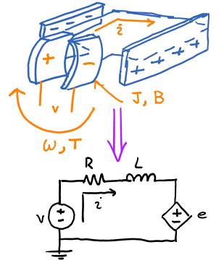

Figure : DC Motor Model

Everyone knows how brushed DC motors work, but to make sure everyone is on the same page here it is. In a two pole brushed dc motor the voltage is applied across two brushes that contact the rotor. This induces a current through the wire that connects the two which produces a stationary magnetic field that opposes the field produced by the permanent magnets. Every half cycle the voltage is reversed which causes the current to reverse direction which causes the magnetic field to reverse direction which allows for the fields to continue to oppose each other.

I am going to model the Brushed DC motor and use that model to introduce the concept of frequency analysis and transfer functions. Equation One says the torque produced by the motor (*T*) is related linearly to the current (*i*) through the constant *KT*.

(1)

Equation Two says the back emf (*e*) is linearly related to the angular velocity (*w*) of the rotor through the constant *KE*.

(2)

Using Kirchhoff’s Voltage Law on Figure One, Equation Three is found.

$v=Ri+L\frac{di}{dt}+e=Ri+L\frac{di}{dt}+K_{E}w$ (3)

Using Newton’s Laws on Figure One, Equation Four is found.

$T=K_{T}i=J\dot{ω}+Bω$ (4)

It is now necessary to introduce the concept of the Laplace and Fourier Transform. The Laplace Transform is a linear integral operation that transforms a time domain signal to the complex domain, see Equation 5. Here *s* is the complex operator and is equal to *σ + jω*, where *j = $\sqrt{-1}$* .

$F\left(s\right)= \int_{-∞}^{∞}{f(t)e^{-st}dt}$ (5)

The Fourier Transform is the Laplace Transform evaluated with the real part (σ) equal to zero. When we do this the complex domain signal is transformed to the frequency domain. However in order for the Fourier Transform to be valid the system must be absolutely integrable as well as linear.

Now, why do we do this? Well it allows for complex linear differential equations to be solved easily as I am about to show. Taking the Laplace Transform of time domain signals is simple (usually) all you need to do is consult the Table of known transforms [here](http://tutorial.math.lamar.edu/pdf/Laplace_Table.pdf) (PDF!). Taking the Laplace transform of (3) and (4).

$V=RI+sLI+K_{E}Ω$ (6)

$K_{T}I=sJΩ+BΩ$ (7)

Using (6) with (7), and solving for $\frac{Ω}{V}$. Here Ω is the output (the angular velocity of the motor) and V is the input (the motor voltage). The ratio of the two polynomials on the right side is called the “Transfer Function”.

$\frac{Ω}{V}=\frac{K_{T}}{\left(sJ+B\right)\left(sL+R\right)+K_{T}K_{E}}$ (8)

Here are some notes on the transfer function:

1. Transfer functions work for single input single output (SISO) systems only. If you have a multiple input multiple output (MIMO) system then you may need to use other methods.
2. The roots of the numerator are called “zeros”, the roots of the denominator are called “poles”. If the real part of the poles are greater than zero then the system is unstable.

Equation (8) is called the “open loop system” because there is no feedback path. If we wanted we could run our system open loop but it wouldn’t be able to compensate for load torque for example. Performance can be improved by using feedback.

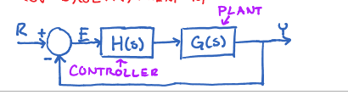

Figure : Closed Loop Plant with Unity Feedback.

Figure Two shows the closed loop motor model. It is simple to see that the Equation for the closed loop dynamics can be seen in Equation (9).

$\frac{Y}{R}=\frac{G(s)}{1+G\left(s\right)H(s)}$ (9)

Applying (9) to (8), the closed loop dynamics are shown in Equation (10). In this case the closed loop system is the same order as the open loop one, and the poles don’t move any appreciable amount.

$\frac{Ω}{R}=\frac{K_{T}}{\left(sJ+B\right)\left(sL+R\right)+K_{T}K_{E}+K_{T}}$ (10)

It will be shown that the system performance can be improved dramatically using a simple proportional integral controller.